Unit 5 Day 8

Today, we are going to look back at some of the things we have already learned.

What are parts and coverings on an animal?

Parts – different things on an animal (mouth, eyes, legs, nose)

Coverings – what covers an animal (fur, skin, scales, feathers)

What are the parts and coverings of a dog?

Parts –

Coverings –

A sentence tells a complete thought. When we write a complete sentence, we need…

* + A **capital letter** at the beginning of the sentence
  + An **end mark**, like a period.
  + A **naming part** – names someone or something
  + A **telling part** – tells what the naming part does

A tiger moves its big paws.

**Name** **Tell**

Can you find the **capital letter** in this sentence?

A flamingo has pink feathers.

Can you find the **end mark** in this sentence?

A flamingo has pink feathers.

Can you find the **naming part** in this sentence?

A flamingo has pink feathers.

Can you find the **telling part** in this sentence?

A flamingo has pink feathers.

When we compare 2 animals, we see how they are alike.

When we contrast 2 animals, we see how they are different.

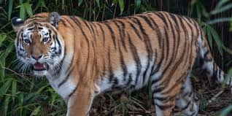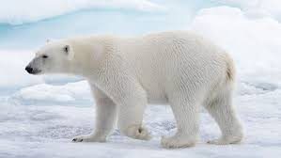 Tiger Polar Bear

How is the tiger and polar bear alike and different?

Activities! You are welcome to do all of these activities but please do at least three of them.

1. Have your child choose two animals and describe how they are alike and different.
2. Have your child choose three different animals and write what parts and coverings each animal has.
3. Have your child point out the capital letter, the end mark, naming part, and telling part of each sentence below.

The alligator likes to swim in the water.

The dog barks at the birds.

The duck dips its head to catch food.

1. Have your child write the word alike and different 5 times each.